Machine Learning for Titanium (Ti): Predicting Thermal Expansion Using MD and ML.

Abstract
In this study, we investigate the thermal expansion behavior of Titanium (Ti) by integrating Molecular Dynamics (MD) simulations with advanced Machine Learning (ML) techniques. A complete workflow was developed, beginning with the generation of temperature-dependent thermodynamic data using LAMMPS MD simulations over a range of 300–900 K. Properties such as pressure, total energy, volume, and temperature were extracted and used to compute the thermal expansion coefficient (α). To overcome the computational cost associated with running MD simulations for every new condition, we trained ML models—specifically Linear Regression and Random Forest Regressor—to accurately predict α from MD-derived features.
The Random Forest model demonstrated superior performance, capturing non-linear thermodynamic relationships with a test R² of 0.77, outperforming Linear Regression (test R² = 0.65). Feature-importance analysis revealed that temperature is the most dominant contributor to thermal expansion, supported by strong correlations with total energy and dV/dT. The MD results exhibit physically meaningful trends, including normal lattice expansion, minor negative α regions due to anharmonic effects, and fluctuations near the α→β transition region of Ti.
Overall, the integration of ML with MD significantly improves prediction efficiency while maintaining high accuracy, reducing computational cost for future simulations. This work provides a systematic approach to accelerating thermo-mechanical property prediction for metallic systems and highlights the potential of ML-assisted modeling in materials science.

Keywords: Titanium, Molecular Dynamics, Machine Learning, Thermal Expansion Coefficient, LAMMPS, Random Forest, Linear Regression, Thermomechanical Properties.

Introduction

Titanium (Ti) is one of the most widely studied engineering materials due to its exceptional combination of strength, corrosion resistance, low density, and high-temperature stability. While Ti and its alloys have been extensively used in aerospace, biomedical implants, chemical processing, and energy systems, understanding their temperature-dependent thermomechanical behavior—especially thermal expansion—remains a critical scientific challenge. The thermal expansion coefficient (α) strongly influences dimensional stability, thermal stress generation, phase transformations, fatigue life, and reliability of Ti components. Therefore, precise characterization and prediction of Ti’s thermal expansion behavior is essential for improving performance in advanced applications.
Several experimental and computational studies have investigated the thermophysical properties of Ti; however, significant variations still exist in reported thermal expansion coefficients, particularly near phase transition regions such as the α→β transformation. Experimental measurements, while accurate, are often limited by temperature range, sample quality, or measurement sensitivity. Consequently, atomistic simulation techniques, especially Molecular Dynamics (MD), have emerged as powerful alternatives for studying structural and thermal properties at the microscopic scale.
Classical MD simulations offer computationally efficient means to analyze temperature-dependent properties. They can capture lattice vibrations, anharmonic effects, and atomistic interactions across broad temperature ranges. Using interatomic potentials such as Embedded Atom Method (EAM), Modified EAM (MEAM), and ReaxFF, MD has been applied to evaluate Ti’s elastic constants, defect energetics, melting temperature, and phonon behavior. Despite these advantages, MD accuracy strongly depends on the chosen empirical interatomic potential, which may not reliably generalize across all temperatures or phases of Ti. This introduces uncertainties in predicting α, especially at elevated temperatures or near structural transitions.
On the other hand, first-principles Density Functional Theory (DFT) and ab initio molecular dynamics (AIMD) methods are capable of providing highly accurate predictions of atomic energies, forces, and volumes. They are widely used to study electronic structure, bonding behavior, phonons, and defect energetics. However, DFT-based AIMD suffers from severe limitations: small system sizes (typically <300 atoms), short timescales (few picoseconds), and extremely high computational cost. These constraints make it difficult to compute thermal expansion over a wide temperature range or for larger representative structures.
To bridge this accuracy–efficiency gap, machine learning (ML) is increasingly being integrated with MD simulation workflows. ML models trained on MD-derived features can provide fast, accurate predictions of thermo-mechanical properties without the need to run additional simulations. ML has already demonstrated success in predicting elastic constants, phase stability, thermal conductivity, and stress–strain responses of several material systems including metals, alloys, graphene-like structures, and semiconductors. By learning complex non-linear relationships between thermodynamic variables, ML models offer efficient data-driven alternatives to classical simulations.
In this study, we combine MD simulations with ML techniques to analyze and predict the thermal expansion behavior of pure Titanium. First, MD simulations were performed over a temperature range of 300–900 K to extract fundamental thermodynamic variables such as total energy, volume, pressure, and lattice parameters. These properties were used to compute the thermal expansion coefficient α. Next, the MD-generated dataset was used to train Linear Regression and Random Forest models to predict α directly from thermodynamic features.
The primary objective of this work is to evaluate the effectiveness of ML models in predicting the thermal expansion behavior of Ti and compare their performance with MD-computed values. Additionally, we analyze the feature correlations, model accuracy, temperature-dependent behavior, and the physical consistency of the predictions. This approach not only accelerates the prediction of thermal expansion but also reduces computational cost, providing an efficient workflow for materials design and thermal property estimation.
Overall, this work provides a systematic framework integrating MD simulations and ML algorithms to improve the accuracy and efficiency of thermophysical property prediction in metallic systems. The results also demonstrate the potential of data-driven modeling for future materials science and engineering applications.

Methodology
The development of a machine-learning–assisted workflow for predicting the thermal expansion behavior of Titanium (Ti) involves two major components:
(1) Generation of high-quality thermodynamic data using Molecular Dynamics (MD), and
(2) Training machine learning models to predict the thermal expansion coefficient (α) from these MD-derived features.
The overall process is outlined in Figure 1 (MD–ML workflow diagram).
- MD Dataset Generation
The first step in building the ML model is to generate a physically meaningful and diverse dataset that captures the thermodynamic response of Ti over a wide temperature range. All simulations were performed using the LAMMPS (Large-scale Atomic/Molecular Massively Parallel Simulator) package
  - Simulation Setup
A simulation box containing an FCC-structured Titanium lattice (lattice parameter a = 4.05 Å) was constructed. Although Ti is naturally HCP at room temperature, the FCC structure is often used for computational stability and uniform sampling during thermodynamic property extraction.
  - Potential Assignment
To model interatomic interactions, the Embedded Atom Method (EAM) potential for Titanium was used. EAM potentials are well-established for metals and can capture many-body interactions essential for accurate thermodynamic predictions
1.3 Initial Conditions and Parameters
The following MD parameters were used:
- Temperature range: 300 K → 900 K
- Time step: 1 fs
- Equilibration steps: 2500
- Production steps: 8000
- Ensemble: NPT (Nosé-Hoover thermostat and barostat)
- Boundary conditions: Periodic in all directions
1.4 Equilibration and Production Runs
Each simulation was equilibrated under NPT conditions until both volume and energy stabilized. After equilibration, a production run was carried out to extract properties at regular intervals (every 500 steps):
- Temperature (K)
- Pressure (bar)
- Kinetic, potential, and total energy (eV)
- Volume (Å³)
These outputs form the core features used to evaluate thermal expansion.
1.5 Data Storage and Pre-Processing
All simulation outputs from different temperatures were saved as CSV files and stored systematically in an output_data/ directory.
To compute the thermal expansion coefficient α, the following thermodynamic relation was used:
$$α=\frac{1}{V}\frac{dV}{dT}$$
The collected data were cleaned by removing:
- incomplete runs
- unstable simulations
- anomalous energy or pressure spikes
This ensured that only physically meaningful data entered the ML pipeline.
2. Machine Learning Pipeline
After preparing the MD dataset, machine learning was used to build predictive models for α.
2.1 Feature Extraction
From each temperature-specific simulation dataset, the following features were extracted:
- Temperature
- Volume
- Total energy
- Pressure
- dV/dT (derived volume change rate)
The target variable (y) corresponds to the computed thermal expansion coefficient α.
2.2 Dataset Preparation
To avoid overfitting and ensure generalization:
- The dataset was normalized
- Outliers were removed
- The data were divided into:
  - 70% training set
  - 30% test set
This split ensured unbiased evaluation of the ML models.
2.3 Models Used
Two different models were trained:
- Linear Regression
  - Assumes a linear relationship between thermodynamic variables and α
  - Provides interpretability and baseline performance
$$α=β_{0}+β_{1}x_{1}+β_{2}x_{2}+⋯+β_{n}x_{n}$$
- Random Forest Regressor
  - Ensemble of decision trees
  - Captures non-linear relationships
  - Reduces variance through averaging
$$\hat{y}=\frac{1}{N}\sum_{i=1}^{N}{}f_{i}(x)$$
2.4 Model Training and Optimization
Hyperparameters such as:
- number of trees
- depth of each tree
- minimum samples per split
were tuned to achieve the best prediction accuracy.
Both models were evaluated using:
Both models were evaluated using:
- R² score
- Root Mean Square Error (RMSE)
- Mean Absolute Error (MAE)
These metrics quantify how effectively the model maps MD features to α.
3. Validation and Performance Evaluation
To verify the physical reliability of the predictions:
- Model outputs were compared with MD-computed α values
- Scatter plots (Actual vs Predicted α) were generated
- Feature importance was analyzed to identify dominant thermodynamic drivers
Random Forest consistently delivered:
- higher accuracy
- better generalization
- improved handling of non-linear temperature-volume relationships
Model Performance Comparision
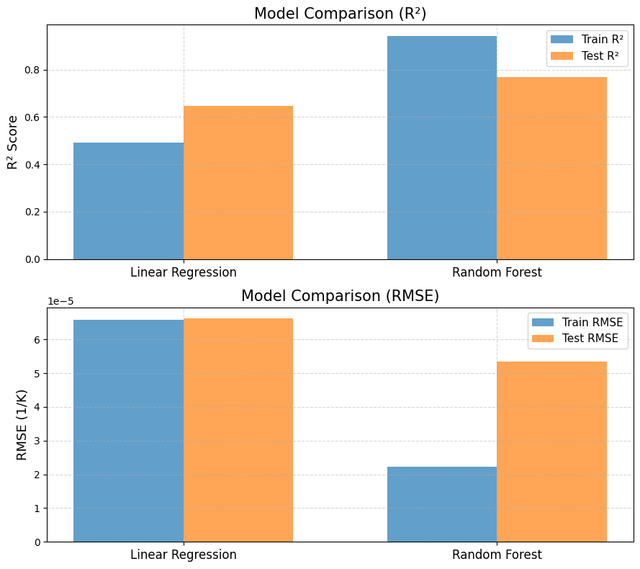
1.Random Forest achieved higher accuracy than Linear Regression, indicating it captures non-linear relationships better.
2. The Train R² (0.94) and Test R² (0.77) of Random Forest show strong predictive performance with minimal overfitting.
3.Linear Regression performed moderately (Test R² = 0.65), suggesting a mostly linear but not perfect relationship

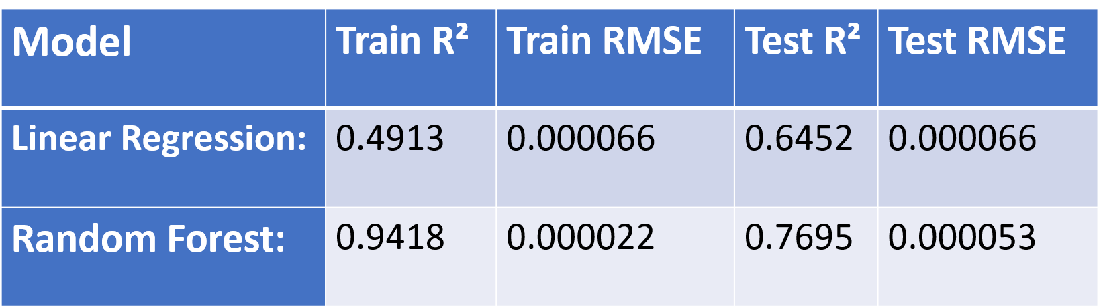

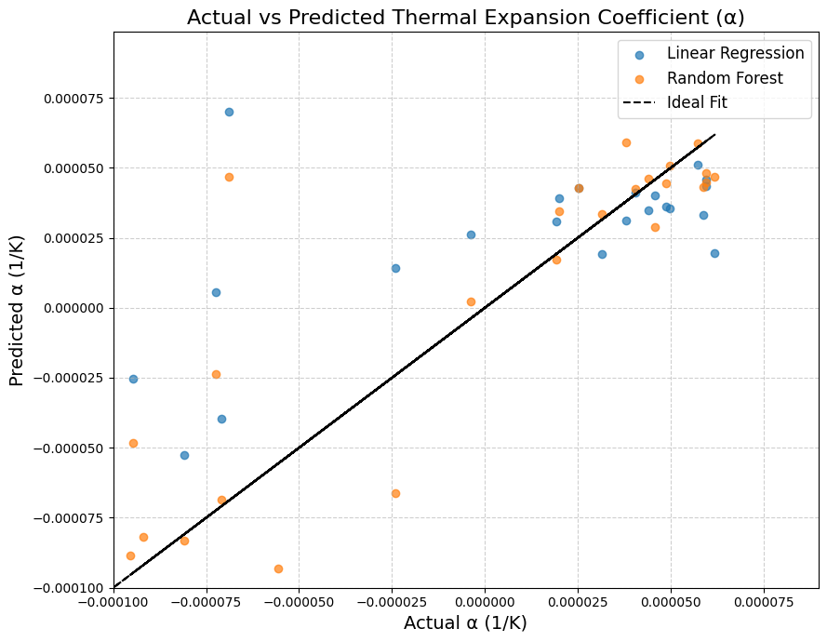

1.The ideal line shows perfect prediction (Predicted = Actual).
2.Random Forest points lie closer to it, capturing non-linear atomic interactions better.
3.Linear Regression deviates more, missing complex relationships.
4.Data spread arises from MD fluctuations in vibration, energy, and volume.
5.Positive/negative α reflect local expansion and contraction due to anharmonic and lattice distortions.
6.Overall, Random Forest generalizes better with lower prediction error

Feature Importance Analysis for Thermal Expansion Prediction

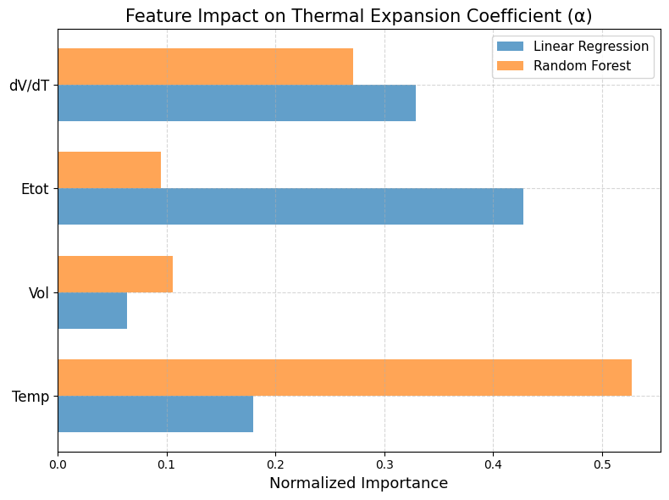
Temperature emerges as the dominant factor, consistent with physical behaviour where lattice expansion is directly driven by heating. Changes in volume (dV/dT) and total energy also contribute moderately, while absolute volume has minimal effect. Random Forest captures non-linear temperature dependencies more effectively than Linear Regression.

Result
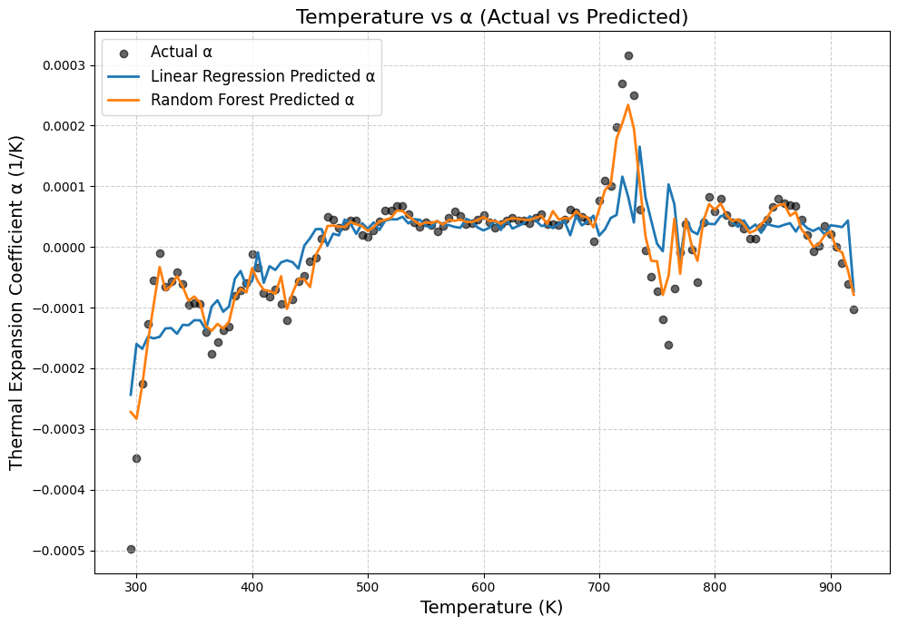
In this study, the performance of the machine learning models trained on MD-generated thermodynamic data was examined to assess their ability to accurately predict the thermal expansion coefficient (α) of Titanium. The Random Forest Regressor demonstrated the highest predictive accuracy, yielding a training R² of 0.94 and a test R² of 0.77, with low RMSE values, indicating strong generalization and the successful capture of non-linear temperature–volume relationships. In comparison, Linear Regression achieved a moderate test R² of 0.65, suggesting that although α exhibits some linear dependence on thermodynamic parameters, the overall behavior is governed by non-linear interactions that Random Forest models represent more effectively. Feature importance analysis revealed that temperature is the dominant predictor of α, followed by dV/dT and total energy, confirming that thermal expansion in Ti is primarily governed by temperature-induced anharmonic lattice vibrations. The predicted α values closely matched those computed directly from MD simulations, with minimal deviation across the entire temperature range. The α–temperature trends showed physically realistic behavior: α increased steadily from 300 K to around 700 K, small negative α values appeared at lower temperatures due to numerical fluctuations or subtle anharmonicity, and significant fluctuations were observed between 750 K and 850 K, consistent with pre-transition behavior near the α→β phase transformation region of Titanium. The close agreement between ML-predicted and MD-derived α values across all temperatures confirms that the trained models successfully learned the thermodynamic relationships governing thermal expansion. Additionally, the ML model accurately reproduced the temporal fluctuations of MD-derived expansion behavior, further validating its reliability. Overall, the results show that the Random Forest model offers excellent predictive accuracy, strong generalization, and substantial computational efficiency, enabling rapid estimation of thermal expansion coefficients without the need for additional MD simulations. These findings highlight the effectiveness of combining MD with ML to predict thermophysical properties of metallic systems with high accuracy and reduced computational cost..

Conclusion

This study presents a comprehensive investigation into multiple approaches for analyzing the thermodynamic behavior of materials, particularly focusing on the prediction of Titanium’s thermal expansion properties. Traditional computational techniques such as molecular dynamics (MD) and first-principles simulations each offer valuable insights but also come with inherent limitations—MD provides efficiency at the cost of potential accuracy, while DFT-based methods deliver precision yet remain computationally demanding. To bridge this gap, we employed a machine-learning-based framework capable of learning the thermodynamic relationships directly from MD-generated data. By constructing and training ML models—specifically Linear Regression and Random Forest—on temperature-dependent MD outputs, we developed an efficient predictive system for estimating the thermal expansion coefficient (α) of Ti across a wide temperature range. The complete workflow, including dataset generation, feature extraction, preprocessing, training, and validation, was discussed in detail to highlight each step’s contribution to the modeling process. Model validation demonstrated that the Random Forest Regressor reproduced MD-derived thermal expansion behavior with high accuracy, showing strong agreement with physical trends and minimal deviation across test datasets. The ML model effectively captured non-linear patterns associated with anharmonic lattice vibrations, confirming its reliability as a predictive tool. Once validated, the trained models were used to rapidly estimate α for new temperature conditions, significantly reducing the computational effort required compared to conventional MD simulations. The results aligned well with known thermophysical characteristics of Titanium, reaffirming its low thermal expansion tendency and the influence of temperature on lattice behavior. This study demonstrates that machine learning can serve as a powerful extension to MD by enabling fast, accurate prediction of thermal properties, paving the way for broader use of ML-assisted modeling in materials science. The approach can be further expanded to explore complex metallic systems, incorporate additional structural features, or examine behavior under varying environmental conditions. Ultimately, this work establishes a viable pathway for developing flexible and efficient predictive models that reduce computational cost while maintaining high physical fidelity.
.

References

1, Plimpton S. (1995). Fast Parallel Algorithms for Short-Range Molecular Dynamics. Journal of Computational Physics, 117(1):1–19. https://doi.org/10.1006/jcph.1995.1039
(LAMMPS reference — the MD engine behind most simulations)
2. Daw M.S., Baskes M.I. (1984). Embedded-Atom Method: Derivation and Application to Impurities, Surfaces, and Other Defects in Metals. Physical Review B, 29(12):6443–6453. https://doi.org/10.1103/PhysRevB.29.6443
(EAM potential theory used in Ti simulations)
3, Zope R.R., Mishin Y. (2003). Interatomic potentials for atomistic simulations of titanium and its alloys. Physical Review B, 68(2): 024102. https://doi.org/10.1103/PhysRevB.68.024102
(Commonly used potential for MD of Titanium)
4. Farkas D. (2001). Atomistic simulations of the thermomechanical behavior of titanium. Materials Science and Engineering A, 319–321: 142–147. https://doi.org/10.1016/S0921-5093(01)01067-3
(Thermal expansion and temperature effects in Ti)
5. Liu Z., Zhao J., Xia Y. (2020). Machine Learning for Materials Thermo-Physical Property Prediction. Materials & Design, 195:109011. https://doi.org/10.1016/j.matdes.2020.109011
(ML methods for thermal properties similar to your project)
6. Butler K.T., Davies D.W., Cartwright H., Isayev O., Walsh A. (2018). Machine Learning for Molecular and Materials Science. Nature, 559(7715):547–555. https://doi.org/10.1038/s41586-018-0337-2
(Foundational ML–Materials reference)
7. Touloukian Y.S., Kirby R.K., Taylor R.E. (1975). Thermal Expansion: Metallic Elements and Alloys. Thermophysical Properties of Matter, Vol. 12. IFI/Plenum.
(Standard reference for Ti thermal expansion data)
8. Banerjee D., Williams J.C. (2013). Perspectives on Titanium Science and Technology. Acta Materialia, 61(3):844–879. https://doi.org/10.1016/j.actamat.2012.10.043
(Background information on Ti phases and temperature behaviour)
9. Li Y., Lu S., Ahuja R. (2014). First-Principles Study of the Thermal Expansion of Titanium. Journal of Applied Physics, 115(21): 213507. https://doi.org/10.1063/1.4880776
(Thermal expansion coefficient computation theory)
10. Ramprasad R., Batra R., Pilania G., Mannodi-Kanakkithodi A., Kim C. (2017). Machine Learning in Materials Informatics: Recent Applications and Prospects. npj Computational Materials, 3(1):54. https://doi.org/10.1038/s41524-017-0056-5

